Discovery Report

Volume 6. Visa EMV and Contactless Issuing

Orient Commercial Bank

Version .2

Status: Updates

Date: 11.02.2020

Prepared by: OpenWay

Author: Tu B. Nguyen

Approved By: Tu B. Nguyen

1. Table of Contents

1. Table of Contents 2

2. History of changes 4

3. Introduction 5

3.1. Notations 5

4. System Overview 6

4.1. Overview 6

5. Visa Issuing Product Requirement 7

5.1. REQC001. VISA Issuing Product 7

5.1.1. Business Requirement 7

5.1.2. Technical Details 7

5.2. REQC002. Client/Contract Hierarchy 8

5.2.1. Business Requirement 8

5.2.2. Technical Details 9

5.3. REQC003. VISA Card Personalization 10

5.3.1. Business Requirement 10

5.3.2. Technical Details 10

5.4. REQC004. VISA Card Operation 11

5.4.1. Business Requirement 11

5.4.2. Technical Details 11

5.5. REQC005. VISA Card Transaction and Service Fees 12

5.5.1. Business Requirement 12

5.5.2. Technical Details 13

5.6. REQC006. VISA Card Usage Limiters 14

5.6.1. Business Requirement 14

5.6.2. Technical Details 14

5.7. REQC008. VISA Card Transaction Reconciliation 15

5.7.1. Business Requirement 15

5.7.2. Technical Details 15

5.8. REQC009. Visa Card Accounting Scheme 16

5.8.1. Business Requirement 16

5.8.2. Technical Details 21

5.9. REQC010. VISA Card Auto Payment 22

5.9.1. Business Requirement 22

5.9.2. Technical Details 22

5.10. REQC011. VISA Card Dispute Management 23

5.10.1. Business Requirement 23

5.10.1. Technical Details 23

5.11. REQC012. VISA Card Instalment 24

5.11.1. Business Requirement 24

5.11.2. Technical Details 24

5.12. REQC013. VISA Corporate Card 25

5.12.1. Business Requirement 25

5.12.2. Technical Details 25

5.13. REQC014. VISA Card Notification 26

5.13.1. Business Requirement 26

5.13.2. Technical Details 26

5.14. REQC015. VISA Card Close 27

5.14.1. Business Requirement 27

5.14.2. Technical Details 27

6. Reports 28

1. History of changes

|  |  |  |  |
| --- | --- | --- | --- |
| version | date | Description | author |
| 0.1 | 27.10.2020 | Initial Version | Tu B. Nguyen |
| 0.2 | 2.11.2020 | Update Version | Sang Tran |
|  |  |  |  |
|  |  |  |  |
|  |  |  |  |

**Copyright**

© OpenWay Asia Limited 2020. All rights reserved.

The Copyright of this complete document and every part it belongs to OpenWay Asia Limited. Proprietary material, brand or product names of other parties or trademarks remain with their respective owners. You may not, except with our express written permission, distribute or commercially exploit the content. Nor may you transmit it or store it in any other website or other form of electronic retrieval system. Any sample data used in examples below are completely fictitious unless otherwise noted.

**Disclaimer**

This document and the OpenWay Asia software it describes are furnished by OpenWay Asia Limited under a Software Licensing Agreement, Consultancy Agreement, Variation Request or Confidentiality Agreement, and may be used or copied only in accordance with the terms of such Agreement. Neither this document nor the OpenWay Asia software it describes may be used, sold, transferred, copied, translated, reproduced or transmitted in any form or by any means, electronic or mechanical, for any purpose, in whole or in part, other than in accordance with the terms of such Agreement, or otherwise without prior written consent of OpenWay Asia Limited.

This document describes a generic product or service and should be read in conjunction with other documents relevant to the configuration of any specific system. The licensee of OpenWay software or user of OpenWay Asia services is responsible for ensuring that the product or service described herein meets its own requirements

**Confidentiality**

The information contained in this Document is the property of OpenWay Asia Ltd and contains CONFIDENTIAL information that is produced solely for the benefit of the receiving party named on the front page of this document. The recipient should keep this document and all its information confidential. On no account should this document, in whole or in part, be used, sold, transferred, copied, translated, reproduced or transmitted in any form or by any means, electronic or mechanical, or disclosed or disseminated to any third party, without the express written permission of OpenWay Asia Ltd.

1. Introduction

This document contains the Configuration Details which the WAY4 Visa EMV and Contactless Issuing will be configured with in order to meet the Business Requirements of Orient Commercial Bank. It covers the different sections of the WAY4 Visa EMV and Contactless Issuing needed to be done in them.

In case a Business Requirements cannot be solved by a system configuration then the same will have to be solved as an Enhancement to the System. Enhancements to the system configuration must be explicitly stated herewith, otherwise configurations described or referenced by this document are assumed to be standard. Enhancements shall not include optional configurations.

* 1. Notations

Notations used in this document are listed in the table below.

***Table 1. Notations***

| Notation | Description |
| --- | --- |
| N | Numeric digits 0 through 9 |
| AN | Alphabetic and Special Characters |
| DT | Date + Format in field description |
| B | Binary representation of data |
| NVAR | Variable length data up to nn characters. There will be two or three character length (depending upon whether maximum data length is 99 or 999) at the beginning of the element to identify the number of positions following to the end of the data element |
| M | Mandatory |
| O | Optional |
| C | Conditional |
| NPA | NAPAS (National Payment Switch) |
| LC | Local Card |
| VISA | Vietnam Chip Card Specificaiton |
| OCB | Orient Commercial Bank |
| OPW | OpenWay |

1. System Overview

## Overview

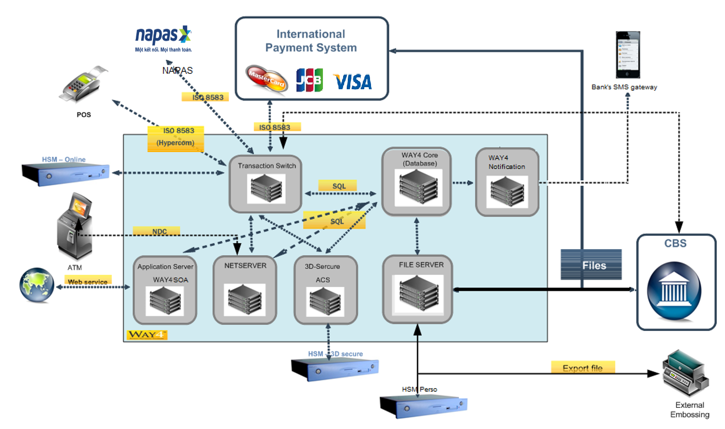WAY4 system was implement on the year 2018. All cardholder and merchant data were migrated from legacy system to WAY4 system. WAY4 system is running until now.

Until now, OCB did implement MasterCard, JCB and Local card to market. In order to provide multi selection to client, OCB want to implement Visa card.

1. Visa Issuing Product Requirement

## REQC001. VISA Issuing Product

### Business Requirement

OCB requests VISA Issuing Product with following characteristics.

* VISA Dual interface (Chip and Contactless interfaces) Card
* VISA must be Contactless enabled
* Magnetic stripe should contain Track data
* PIN should be constructed based on Bank’s Visa Card PAN
* WAY4 needs to be able to support Visa’s network connection and online message format.
* Support for all different products provided by Visa and additional services is required.
* WAY4 should also support loading of all files from Visa, including Clearing and Settlement Files, Visa Parameter Update Files etc. as well as sending mandatory Outgoing files to Visa.

|  |  |  |  |  |  |
| --- | --- | --- | --- | --- | --- |
| No | file name | description | way4 support |  |  |
| 1 | EPIN02.TXT | Daily Incoming File (ITF) | Yes |  |  |
| 2 | VSOUTS33.DDD | Daily Outgoing File (CTF) | Yes |  |  |
| 3 | EpArdefExt.txt | BIN Visa Weekly Update (ARDEF) | Yes |  |  |
| 4 | EP-756 | Exchange rate of VS | No |  |  |
| 5 | DSS.txt | Reconciliation report | No |  |  |

### Technical Details

WAY4 will support the setup and configuration for the VISA Contact/Contactless Chip Card features supported based on current Visa scheme.

## REQC002. Client/Contract Hierarchy

### Business Requirement

It is required by OCB for VISA Issuing products to have the same hierarchy as current Issuing products in Bank. Below is list of current local card products.

VISA Credit Products:

|  |  |  |  |  |  |
| --- | --- | --- | --- | --- | --- |
| No | Level | Meanings |  |  |  |
| 1 | Liability | Manage Share Limit |  |  |  |
| 2 | Issuing Contract | Manage statement, billing cycle |  |  |  |
| 3 | Card Contract | Manage card transaction, fee |  |  |  |

VISA Debit Products:

|  |  |  |  |  |  |
| --- | --- | --- | --- | --- | --- |
| No | level | meaning |  |  |  |
| 1 | Issuing contract | Manage balance |  |  |  |
| 2 | Card Contract | Manage card transaction and fee |  |  |  |
| 3 | Related card | Manage Bank account linked to each card |  |  |  |

VISA Prepaid Products:

|  |  |  |  |  |  |
| --- | --- | --- | --- | --- | --- |
| No | level | meaning |  |  |  |
| 1 | Issuing contract | Manage balance |  |  |  |
| 2 | Card Contract | Manage card transaction and fee |  |  |  |

### Technical Details

Way4 will support to integrate new VISA Issuing products to current system.

## REQC003. VISA Card Personalization

### Business Requirement

BANK will generate personal data like: PIN, (PVV), CVV/CVC, CVV2/CVC2 and iCVV/Chip CVC security values. EMV Keys diversification will be also performed by 3d Party Personalisation Bureau.

BANK needs to be able to provide some EMV parameters like velocity checking parameters for instance to the 3rd party personalization bureau. The following will be embossed on the cards:

* PAN
* Emboss Name
* Expiry Date
* CVC2 printed on back side of the card.

### Technical Details

Currently, there is interface of personalization data between WAY4 and 3rd party. We should apply the interface format as same as JCB existing interface.

## REQC004. VISA Card Operation

### Business Requirement

This section describes OCB’s VISA Card Operation requirements.

* Card Numbering, Expiration Date, PIN Mailer

|  |  |  |  |  |  |
| --- | --- | --- | --- | --- | --- |
| No | Product | validation period | bin | min | max |
| 1 | Credit | 36 months |  |  |  |
| 2 | Debit |  |  |  |  |
| 3 | Prepaid |  |  |  |  |

PIN Mailer format is kept as existing one.

* Card Activation
  + The same requirement with existing Card.
* Card Renewal/Replacement
  + The same requirement with existing Card.
* Card ReOrder PIN
  + The same requirement with existing Card.
* Card Customer Service
  + The same requirement with existing Card.
* Card Blocking
  + The same requirement with existing Card.

### Technical Details

WAY4 supports this requirement as standard function.

## REQC005. VISA Card Transaction and Service Fees

### Business Requirement

The set of transaction types permitted depends on the Product

* The following transaction sources are allowed:
  + Own devices
  + Foreign devices (Visa Acquire)
* The following restrictions take place for card:
  + ON/OFF ecommerce transaction (ON by default)
  + ON/OFF Moto transaction (OFF by default)

OCB needs the ability to define the fees in the system. Fee can be defined as a charge to a cardholder or it can be some sort of incentive to a cardholder.

OCB needs to have several fees combined for a single operation e.g. fee for ATM withdrawal + processing fee + mark-up on authorization.

The Fee Amount (whether a fixed amount, a percentage, or a combination) should be configurable per Product/Contract.

Fees can be posted either at Card level or at Issuing Contract level.

Once a Fee is posted, the history of when the Fee was posted, for what amount, and who posted the Fee (Operator OR System) must be kept. It should be possible to query that history.

OCB requires two main types of fees:

* Misc. Fees: fees which are configured for management or event. They are non-transaction based fees. Misc. Fees can be manual or automatic.
* Transaction Fees: fees applied on financial transactions, e.g. card loading fee, mark-up, processing fee. Transaction Fees are always automatic

|  |  |  |  |  |  |
| --- | --- | --- | --- | --- | --- |
| No | Transaction fee | applied condition | calculation | applied auth & fin |  |
| 1 | Cash fee | MCC in 6010,611 | fee% + fee base | Both |  |
| 2 | Processing fee | Tran currency <> VND | fee% | Both |  |
| 3 | Markup fee | Tran currency <> VND | fee% | Both |  |
| 4 | Cross-border | Transaction currency = 704 & Merchant country code # 704 | fee% | Both |  |
| 5 | Additional hold | Tran currency <> VND | fee% | Auth only |  |
| 6 | Visa FastFunds | Fast Funds transaction | fee% | Both |  |

**Transaction Fee**

Attached file is transaction fee for credit/debit/prepaid card. (OCB provide the file)

**Misc Fee**

Attached file is Misc fee for credit/debit/prepaid card. (OCB provide the file)

### Technical Details

Way4 will support this function as standard.

## REQC006. VISA Card Usage Limiters

### Business Requirement

OCB requires having flexible mechanism to assign, change and control Usage limits. The parameters should include:

* Conditions:
  + On-Us: Yes/No
  + Area: Vietnam/Outside of Vietnam
  + Transaction Type: Sale, Cash
  + MCC
  + Periodicity: daily, weekly, billing
* Limits:
  + Total Amount (over the period)
  + Single Amount (per transaction)
* Consequences:
  + Response Code

The Limit values (amounts) are flexible and can be different per Product/Contract according to the assigned Plan. That is, two Products/Contracts can share the same Usage Limiter (same Conditions/Consequences) but use different Limits (Amounts).

Below is list of Usage Limiters

OCB provides the list

### Technical Details

It keeps the existing functions. No change is required.

## REQC008. VISA Card Transaction Reconciliation

### Business Requirement

This section describes OCB’s VISA Card Transaction Reconciliation requirements.

**Interface**

CMS will certify Visa for issuer mode interface for Credit/Debit/Prepaid BINs. The transactions will be routed to CMS through CMS from Visa.

**Settlement and clearing**

CMS also supports offline/stand-in mode and E-Commerce transactions or others mandatory transactions followed to Visa’s rules.

The system complies with the rule of Visa settlement and clearing.

### Technical Details

These features are fully supported by WAY4 as standard functionality.

## REQC009. Visa Card Accounting Scheme

### Business Requirement

This section describes OCB’s VISA Card Accounting scheme requirements.

The WAY4 system will be performing Accounting for the Credit Cards, Debit Card and also the Prepaid Cards.

Accounting Schemes is a product component that is composed of a set of account templates defining properties of each account under a Contract. It is used to create a set of analytic accounts for the contract and automatic posting of macro-transactions to contract accounts. The Accounting Scheme is a mandatory element of the Contract. The Accounting Scheme includes Standing Orders and Events and can be used to setup Billing information, Interest Calculation, Bucket Ageing, Messages etc.

**PrePaid Card Accounting Scheme**

*Account List*

|  |  |  |  |  |  |
| --- | --- | --- | --- | --- | --- |
| No | account type | account name |  |  |  |
| 1 | Cardholder | CH Current/Credit |  |  |  |
|  |  | Dispute |  |  |  |
| 2 | Bank | Fine, penalty and fee revenues |  |  |  |
|  |  | Account for correspondence with passive accounts |  |  |  |
|  |  | Account for correspondence with active accounts |  |  |  |
|  |  | Fee reserves |  |  |  |

Please note that the exact set of accounts will be finalized only during the Implementation Phase. It will be applied same accounting scheme as MasterCard/JCB card.

*Billing Information*

* Billing cycle
  + Monthly
  + Daily send Financial flows
* Statement Date
  + Monthly
  + Can be setup as any day in the Month
* Settlement
  + Daily Auto Settlement or Import settlement file
* Ageing
  + No Aging for Prepaid Cards

**Credit Card Accounting Scheme**

*Account List*

|  |  |  |  |  |  |
| --- | --- | --- | --- | --- | --- |
| No | account type | account name | piorities |  |  |
| 1 | Cardholder | CH Current/Credit | 0 |  |  |
|  |  | Dispute | 0 |  |  |
|  |  | Open Sale | 1 |  |  |
|  |  | Open Cash | 2 |  |  |
|  |  | … |  |  |  |
|  |  | Grade Sale | 3 |  |  |
|  |  | Grade Cash | 4 |  |  |
|  |  | … |  |  |  |
|  |  | Close Sale | 5 |  |  |
|  |  | Close Cash | 6 |  |  |
|  |  | … |  |  |  |
|  |  | OVD Sale | 7 |  |  |
|  |  | OVD Cash | 8 |  |  |
|  |  | … |  |  |  |
| 2 | Bank | Revenue account for fees |  |  |  |
|  |  | Revenue interests |  |  |  |
|  |  | Provision accounts |  |  |  |

Please note that the exact set of accounts will be finalized only during the Implementation Phase. It will be applied same accounting scheme as MasterCard/JCB card.

*Billing Information*

* Billing cycle
  + Monthly
  + Fixed day in the month
* Statement Date
  + Fixed day in the month (currently is *15 monthly, bank can re-configure later*)
* Grace Period
  + 0 days
  + Fixed day in the month
* Due Date
  + Based on the Statement day (currently is *15 days is from statement days, bank can re-configure later*)
  + Fixed day in the month

We apply billing date and due date as existing date of MasterCard/JCB Card.

|  |  |  |  |  |  |
| --- | --- | --- | --- | --- | --- |
| No | Product | Billing date | due date |  |  |
| 1 | Credit Classic | ??? | ??? |  |  |
| 2 | Credit Gold |  |  |  |  |
| 3 | Credit Platinum |  |  |  |  |

*OverLimit*

* Over Limit Fees will not be charged.
* Interest rate of over-limit - Refer to the section Interest.
* Bank allows any over-limit amount.

*Bucket*

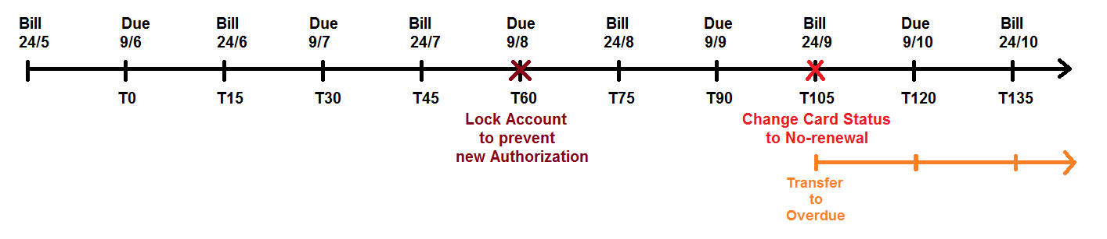After 2 consequent late cycles then card/issuing contract will be locked to stop new authorization (at T60). If cardholder still did not pay amount for next cycle and a half (at T105) then all cards under issuing contract will be locked to no-renewal status. At no-renewal status, end-user cannot change to other status. It means that card is closed forever.

OCB did not apply to lock card, apply to lock the issuing contract level at T60.

What is card status to be changed to Lock by Debt?

* + - Card Ok
    - Card do not honor

Bank has facility to set up event to change Account status automatically following delinquency status.

*Interest Calculation Principle*

Purchase transactions for the first cycle are free of interest. Interest calculation is done from statement date to statement date (Closing daily balance interest calculation) and applies if the cardholder does not pay the full amount by the due date.

The periodical (monthly) computation of interest are depending on the real number of days within each period

~~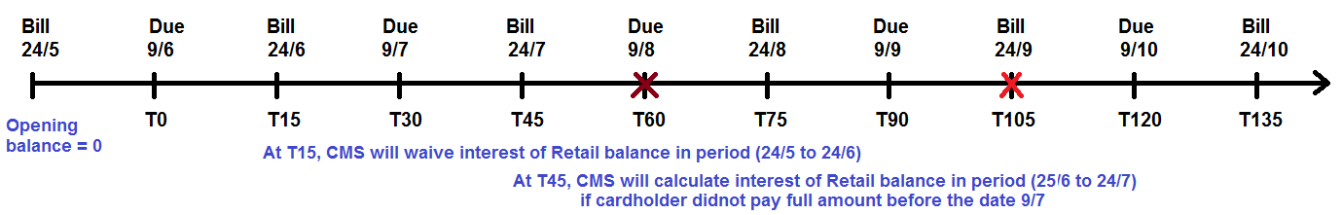~~

Note: Interest calculated for current cycle will be integrated in the balance of the next cycle. Therefore interest will then also be computed on the interest.

Note: All fees (including annual fees) are included into the balance and therefore subject to interest calculation.

Interest for Purchase transaction will not be calculated in following cases:

* + Opening balance is greater than zero
  + Customer pays full before Due date

*Interest Formula*

Interest is accrued for the amount (outstanding balance (including fees)) using the following formula:

***Annual Interest Rate X % *(Outstanding Balance) * number of days / days per year***

Interests from the previous cycle are integrated into the balance of the current cycle.

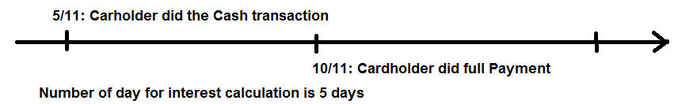Cash Interest Amount calculated from the date of cash transaction debited on card account until the date that cardholder pays all debited amounts arises by cash transaction. Cash Interest Amount will not be excepted in any case.

Note: we assume that transaction is executed on 5th Nov 2015 and cardholder has paid on 10th Nov 2015 then ORIENT COMMERCIAL BANK want number of days to be 5 when CMS calculating interest.

Interest Amount calculated in case cardholder does not pay or only pays one part of closing balance or pays after min due date.

*Interest Rate*

It is required to be able to define different interest rates as follows:

* Due Rate for Cash
* Due Rate for Retail
* OverDue Rate
* Overlimit Rate

Accounts can be setup in WAY4 with different priority such that when a payment is received, it is used to first payoff outstanding amount in accounts with a higher priority (typically accounts which have higher interest rate are paid off first).

It is also requested to have the ability to automatically re-compute interests after a transaction reversal in current cycle.

| **No** | **Delinquency** | **Client Classifier** | | | | | | | |
| --- | --- | --- | --- | --- | --- | --- | --- | --- | --- |
|  |  | **Staff** | **Normal** | **Saving** | **VIP** | **CCEH1** | **CCEH2** | **CCEP1** | **Zero** |
| 1 | In Due | ?? |  |  |  |  |  |  |  |
| 2 | Overdue | 150% of In Due rate | | | | | | | |
| 3 | Overlimit | 0 | 0 | 0 | 0 | 0 | 0 | 0 | 0 |

*Minimum Amount Calculation*

Min due: calculated in the percent of closing balance.

**Debit Card Accounting Scheme**

*Account List*

|  |  |  |  |  |  |
| --- | --- | --- | --- | --- | --- |
| No | account type | account name |  |  |  |
| 1 | Cardholder | CH Current/Credit |  |  |  |
|  |  | CL Loan |  |  |  |
|  |  | Dispute |  |  |  |
| 2 | Bank | Fine, penalty and fee revenues |  |  |  |
|  |  | Account for correspondence with passive accounts |  |  |  |
|  |  | Account for correspondence with active accounts |  |  |  |
|  |  | Fee reserves |  |  |  |

Please note that the exact set of accounts will be finalized only during the Implementation Phase. It will be applied same accounting scheme as MasterCard/JCB card.

*Billing Information*

No billing cycle for debit card.

*Ageing*

No Ageing for Debit Card.

### Technical Details

These features are fully supported by WAY4 as standard functionality.

## REQC010. VISA Card Auto Payment

### Business Requirement

Way4 support for uploading file payment (Payment file A)

Auto payment for credit card

Cardholder registers payment type (minimum or full payment)

CMS will export offline file of cardholder debt to import to Core Banking System (Debt File B).

Core Banking System will settle cardholder’s debt.

Core Banking System will export offline file to import to CMS (Payment File C).

Format of payment file A, B and C should be applied as same as existing files of MasterCard/JCB.

### Technical Details

These features are fully supported by WAY4 as customized functionality.

## REQC011. VISA Card Dispute Management

### Business Requirement

OCB will apply Dispute cycle of Visa Card using Visa online system. Therefore, this function have not need to apply in WAY4.

### Technical Details

These features have not applied in WAY4.

## REQC012. VISA Card Instalment

### Business Requirement

OCB will apply Instalment for Visa Credit Card. The following features are required:

* Ability to define instalment agreement
* Define time of reimbursement
* Convert Transaction into Instalment
* Ability to produce reports on instalment to the issuer and/or the cardholder
* Summary of reimbursement at the end or on demand
* Interest is not charged for the instalment transaction.
* The periods can be 3 months, 6 months, 9 months, 12 months or other periods defined by ORIENT COMMERCIAL BANK.
* Card Holder can register one or more instalment transaction(s)
* Bank has option to configure apply fee charge in case Card Holder request to terminate the instalment transaction(s) by due date.

ORIENT COMMERCIAL BANK want to apply WAY4 standard instalment. For instalment flow is brief as below:

* Cardholder did the purchase transaction
* Cardholder can call/contact to bank to request his/her transaction to convert to instalment transaction
* Teller will convert the transaction to instalment scheme
* Instalment scheme will be applied the period as 3,6,9,12 month…
* WAY4 will create total instalment amount in Total Principal waiting account and principal waiting for each billing cycle. Number of principal waiting record is number of month of particular instalment scheme which cardholder want to apply
* Each billing cycle, system will change one principal waiting from WAITING status to OPEN.
* If Cardholder did not pay then status of principal waiting will be changed to OVERDUE
* If Cardholder pays partial amount the status of principal waiting will be changed to PARTIAL
* If Cardholder pays full amount the status of principal waiting will be changed to CLOSE

Finally, OCB want to apply Instalment of Visa Card as same as Master/JCB card’s existing one.

### Technical Details

These features are fully supported by WAY4 as standard functionality.

## REQC013. VISA Corporate Card

### Business Requirement

Bank can issue corporate cards with individual or corporate liability.

Individual cards will have individual accounts, statements would be separate for every card and would be mailed to the cardholders. There needs to be a summary statement for corporate which will give details of outstanding of all cards under that corporate.

In Corporate Profile any change in Corporate Name or address, the history to be stored.

There need to be a linkage of all Corporate Cards issued to a Corporate to block all Cards of the Same Corporate if any one of same defaults in payment. The blocking has to be done manually by the bank.

At present, OCB applied the Product’s feature of corporate card similar to product of private credit card and client.

### Technical Details

These features are fully supported by WAY4 as standard functionality.

## REQC014. VISA Card Notification

### Business Requirement

ORIENT COMMERCIAL BANK would like the ability to communicate with the Cardholder over three different channels: SMS and email.

Notification is setup for:

* Transaction is executed
* Balance change
* Payment reminder

OCB want to apply notification rule as same as MasterCard/JCB rules.

### Technical Details

These features are fully supported by WAY4 as standard functionality.

## REQC015. VISA Card Close

### Business Requirement

Way4 supports end user for changing the card status on form whenever the card holder request or the bank decide base on internal policy.

OCB want to apply Visa Card Closure rule as same as MasterCard/JCB rules.

### Technical Details

These features are fully supported by WAY4 as standard functionality.

1. Reports

No report is requested.s